Лабораторная работа № 2

Задание 1

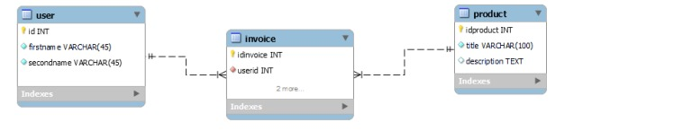

https://github.com/Banakov/BD4/blob/main/код%20к%20лр2

-- -----------------------------------------------------

-- Table `firstModel`.`invoice`

-- -----------------------------------------------------

CREATE TABLE IF NOT EXISTS `firstModel`.`invoice` (

`idinvoice` INT NOT NULL AUTO_INCREMENT,

`userid` INT NOT NULL,

`productid` INT NOT NULL,

`cost` DECIMAL(10,2) NOT NULL,

PRIMARY KEY (`idinvoice`),

INDEX `user_idx` (`userid` ASC) VISIBLE,

INDEX `prod_idx` (`productid` ASC) VISIBLE,

CONSTRAINT `user`

FOREIGN KEY (`userid`)

REFERENCES `firstModel`.`user` (`id`)

ON DELETE CASCADE

ON UPDATE CASCADE,

CONSTRAINT `prod`

FOREIGN KEY (`productid`)

REFERENCES `firstModel`.`product` (`idproduct`)

ON DELETE CASCADE

ON UPDATE CASCADE)

ENGINE = InnoDB;

Задание 2

Задание 3

